MEDIA RELEASE

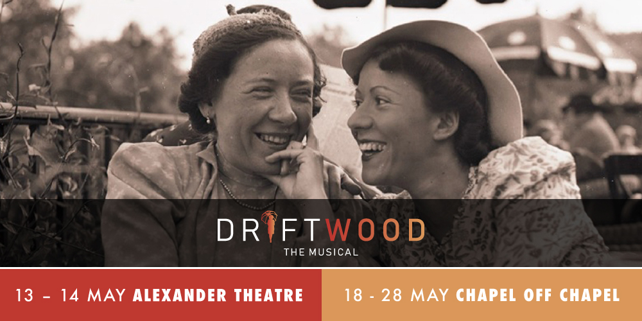
An epic story of love, courage, survival …. and foldable umbrellas
based on Eva de Jong-Duldig’s memoir

WORLD PREMIERE
Directed by Wesley Enoch AM
Starring Tania de Jong AM, Anton Berezin, Fem Belling, Sara Reed and Troy Sussman
Adapted for the stage by award-winning playwright Jane Bodie
Musical Direction and Composition by Anthony Barnhill

Driftwood – The Musical is the inspirational story of renowned Austrian/Australian sculptor Karl Duldig and his artist/inventor wife, Slawa Horowitz-Duldig, based on Eva de Jong-Duldig’s critically acclaimed memoir. Adapted for stage by award-winning playwright Jane Bodie and directed by celebrated theatre maker Wesley Enoch with musical direction and original music composition by Anthony Barnhill, the production makes its world premiere at Alexander Theatre and Chapel off Chapel this May.
The musical theatre work follows Karl and Slawa’s romantic and artistic lives in pre-war Vienna, Slawa’s ingenious invention of the foldable umbrella and their miraculous escape from the Holocaust to living out their lives as artists in Melbourne.
Driftwood – The Musical is a magical story of art and creativity, survival and perseverance, family, freedom and love. It is also the story on of one woman's ingenuity, invention and adaptability.
“Driftwood is a show not of our time but for our time. History has so many lessons to teach us and, as we start to recover from a once-in-a-century pandemic, we are reminded of our resilience and the collective power of the human condition. Through historic narratives we can demonstrate to the future known ways forward, vocabularies of change and the human instinct to tell stories that unite us. Karl and Slawa’s story is a deeply moving and compelling one. With the power of music and the human voice we are very excited to bring this gripping drama to stage,” said Enoch.

Karl Duldig and Slawa Horowitz-Duldig’s granddaughter, acclaimed Soprano Tania de Jong AM performs the lead role of Slawa.
“The work poignantly explores the loss that families encounter when they are dislocated by war, whilst illuminating an immigrant experience that is uniquely Australian. I am so inspired to be playing the role of my extraordinarily creative grandmother who invented the foldable umbrella,” said de Jong.
Actor and singer, Anton Berezin who recently performed with Opera Australia in Evita and whose theatre credits include Sweeney Todd, Wicked, The Producers, Side Show Alley, How To Succeed in Business plays the male lead role of Karl. Playing Slawa’s sister Rella is celebrated jazz songstress and musical theatre actor Fem Belling (The Boy From Oz, Hairspray and Fame).
Sara Reed whose musical theatre credits include Billy Elliot: The Musical, Jane Banks in Cameron Mackintosh’s Mary Poppins and Bielke in Fiddler on the Roof opposite Anthony Warlow plays Eva, whilst Troy Sussman (Aladdin, Les Miserables Australian and West End productions) plays multiple roles, rounding out the all-Jewish cast.
The production’s Musical Director and Composer, Anthony Barnhill has conducted performances at renowned opera houses around the world including Berlin State Opera and Sydney Opera House as part of the 2019 international tour of West Side Story (Opera Australia, GWB entertainment, BB group). His other musical theatre credits include Chicago (GFO), Evita (OA) and Oklahoma! (The Production Company). Anthony has recently been named Music Director for Opera Australia’s Phantom of the Opera 2022 season.
Selected for the VCE drama list, Driftwood is more than a memoir. It is an inspiration. Eva de Jong-Duldig weaves her remarkable story of escaping the Holocaust and overcoming its ghosts to find the key to freedom.

CREATIVE TEAM:
Director Wesley Enoch AM
Playwright Jane Bodie
Composer Anthony Barnhill
Designer Charlotte Lane

CAST:
Tania de Jong A, (Slawa Horowitz)
Anton Berezin (Karl Duldig)
Fem Belling (Rella Horowitz-Laisné)
Sara Reed (Eva)
Troy Sussman (Ignaz/Marcel/others)

EVENT DETAILS:
Seasons: 13 - 14 May 2022 at Alexander Theatre, Monash University
Fri 1pm & 7.30pm, Sat 2pm & 7.30pm
18 -28 May 2022 Chapel Off Chapel in Prahran
Tue 7:30pm, Wed & Thu 1pm & 7:30pm, Fri 7:30pm, Sat & Sun 2pm & 7:30pm
Tickets: Standard $59, Concession $49, School Students & Teachers $29
Bookings: Monash Chapel off Chapel
Duration: 2 hours including interval Age Suitability: Recommended for ages 12+
Note: References to violence during World War 2; Use of theatrical haze.
More information: www.driftwoodthemusical.com.au

MEDIA INQUIRIES: Michaela Hall – 0419 113 633 | michaela.hall@bigpond.com

