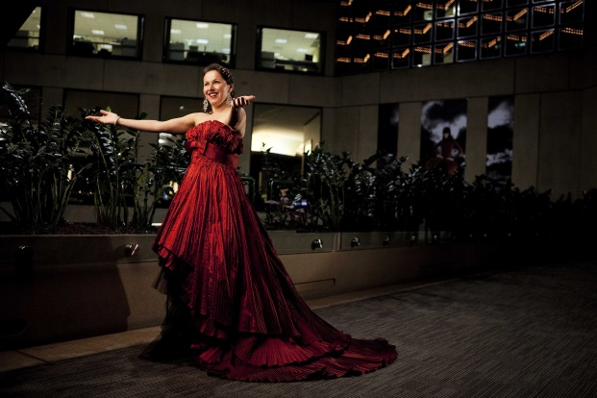
Tania de Jong AM is an acclaimed soprano who presents magical performances across classical, music theatre, contemporary, sacred, spiritual and world genres. She also MCs and presents keynote speeches, voice workshops, immersive sound experiences and uses voice as a healing modality. She creates heartfelt music and performances for meditation and prayer, tribute, reflection, inspiration and illumination.
Tania is a spiritual journey woman, creative alchemist and social entrepreneur. She is the Founder of three charities, Mind Medicine Australia, The Song Room and Creativity Australia and the With One Voice program, and Creative Universe, Creative Innovation Global, Dimension5, Pot-Pourri and MTA Entertainment & Events.
Opera Opera Magazine described Tania as “…. gorgeous, golden-voiced and theatrical…what a talent.” Tania has studied in Australia, UK and Italy with the world’s leading vocal coaches. She performed with the Victoria State Opera and has appeared as a soloist in operas and musicals and with orchestras, festivals, corporate, private and special events globally.
Her internationally renowned singing group Pot-Pourri have released 7 albums and performed in over 40 countries at major festivals, concert halls and special events including with the Seoul Symphony Orchestra at the Seoul Arts Centre in Korea, Hannover World Expo in Germany, Macau Concert Hall, tours of China, USA, Fiji, Vanuatu, New Zealand, Malaysia, Hong Kong, Vietnam, Phillipines, Thailand, Japan, Singapore, Taiwan, Italy and more.
Tania holds graduate and postgraduate degrees from the Victorian College of the Arts (Voice, Opera and Music Theatre). She has a Bachelor of Law (Honours) from the University of Melbourne.
She was appointed a Member of the Order of Australia in June 2008 for service to the arts as a performer and entrepreneur and through the establishment and development of music and arts enrichment programs for schools and communities.
There have been over 110,000 views of her TED Talk: “How singing together changes the brain”.

Tania has released 5 solo albums, Soundsations, Heaven on Earth, Flying Free, The Breezes at Dawn have Secrets to Tell and Solitary Harmony. Tania mission is to change the world, one voice at a time!

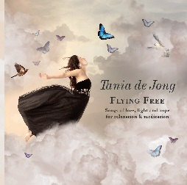
“Flying Free is gorgeous. Tania has a beautiful and moving voice. Some graffiti on a wall said, ‘Without music, life would not be fair.’ After hearing you sing some favourites of mine, I’d say, ‘Without Tania, life would not be fair.’”
Dan Millman, Mindfulness expert and author of best-selling Way of the Peaceful Warrior

“In Flying Free, Tania de Jong’s soaring soprano brings classical and popular favourites, mantras and original compositions to life, creating a light-filled soundtrack for relaxation, inspiration and meditation.” Danielle Kirk, Editor, Wellbeing Magazine

“Everyone was entranced by your performance!” Mirvac

“Tania, I want to commend the beauty of your voice and thank you for the gift you brought to Rhetorica in Chartres, France. Your voice is transcendental and you have much to offer the world.” Jim Garrison, President Wisdom University

(Trivia: Tania’s grandmother Slawa Duldig invented the first foldable umbrella in Vienna in 1929. Tania attended college in the USA on a tennis scholarship.)
Visit: www.taniadejong.com email: tania@creativeuniverse.com.au phone: +61 (0)3 8679 6000

